**MACHINE LEARNING**



Disusun Oleh:

Nama : Ilpan

NPM : 41155050210046

Kelas : A – 2

**TEKNIK INFORMATIKA**

**FAKULTAS TEKNIK**

**UNIVERSITAS LANGLANGBUANA**

**2024**

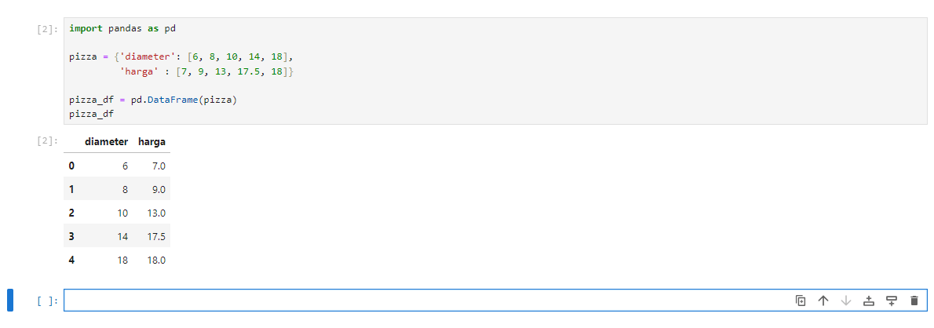**Sample dataset**

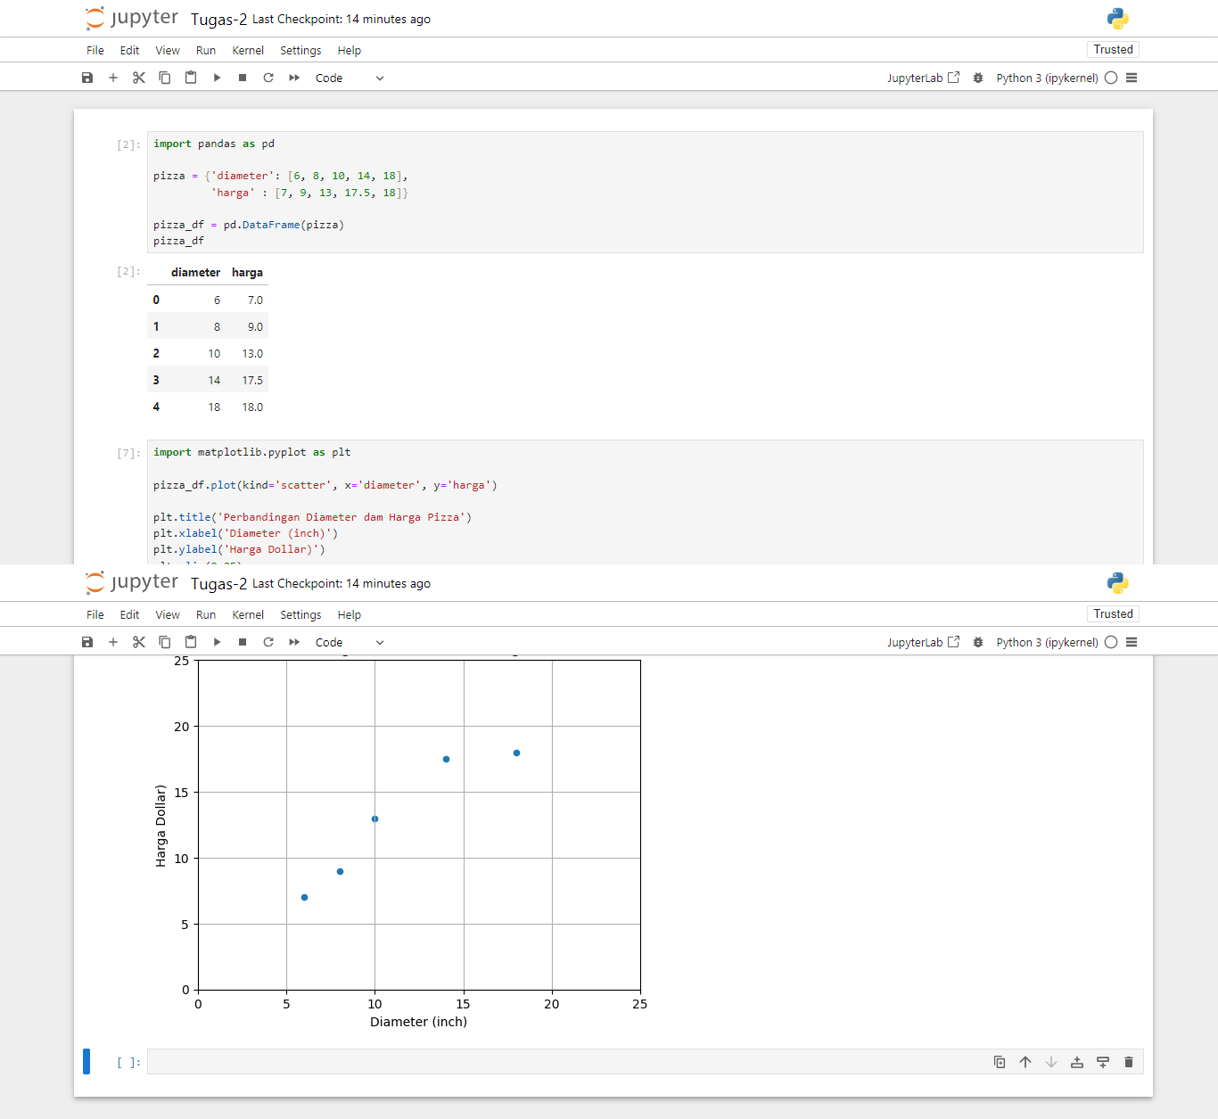**Visualisasi dataset**

**Transformasi dataset**

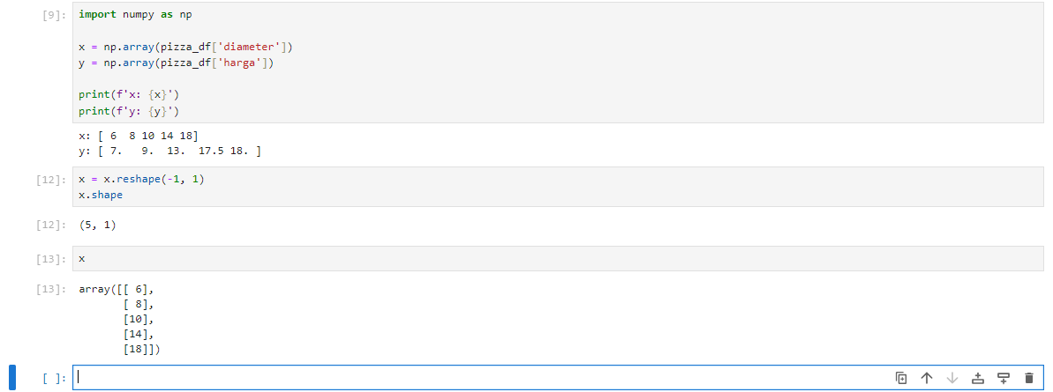

**Training Simple Linear Regression Model**

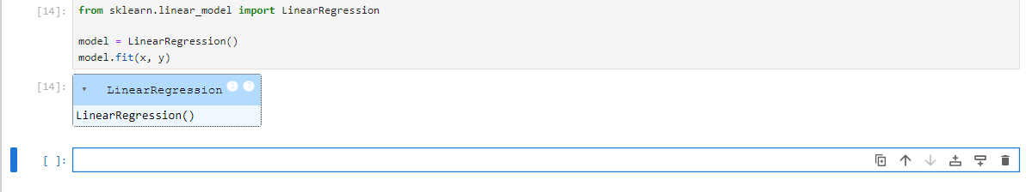

**Visualisasi Simple Linear Regression Model | Penjelasan persamaan garis linear**

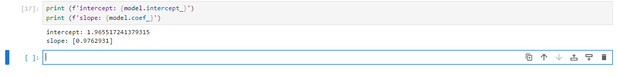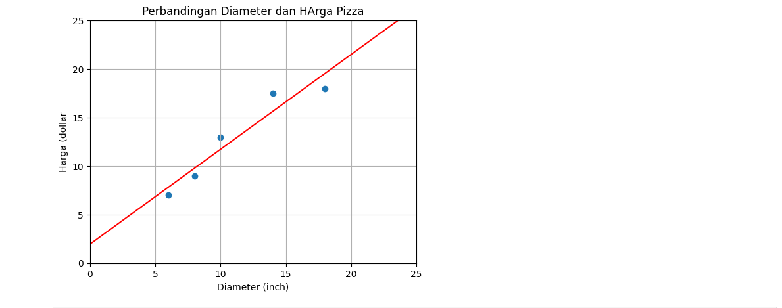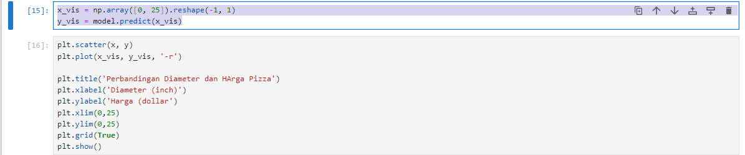

**Kalkulasi nilai slope**

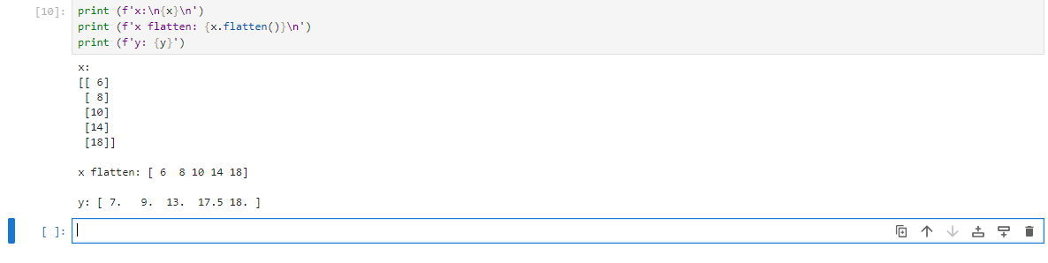

**Variance**

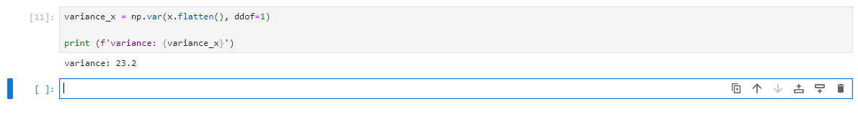

**Covariance**

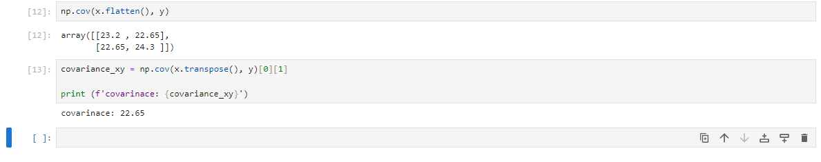

**Slope**

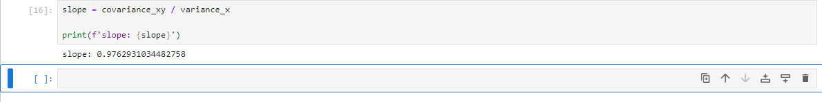

**Kalkukasi nilai intercept**

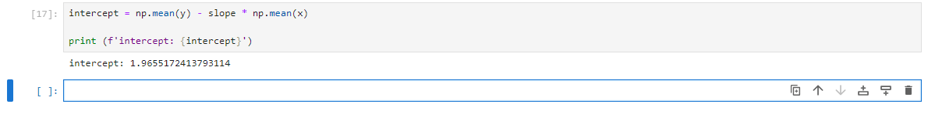

**Prediksi harga pizza dengan Simple Linear Regression Model**

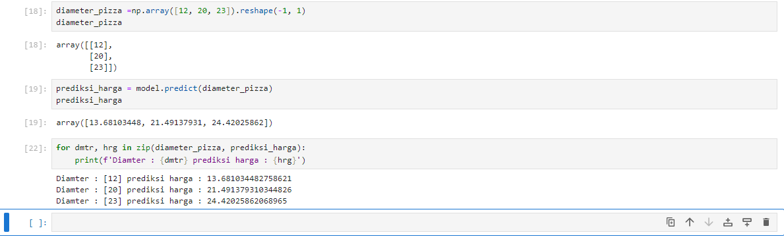

**Evaluasi model dengan Coefficient of Determination | R Squared**

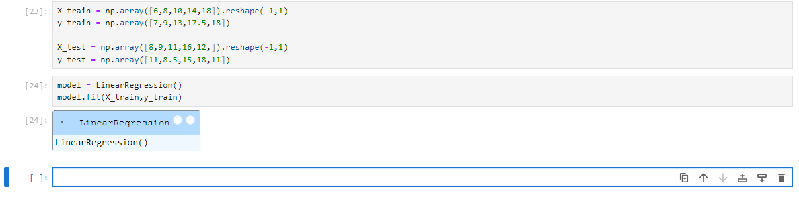

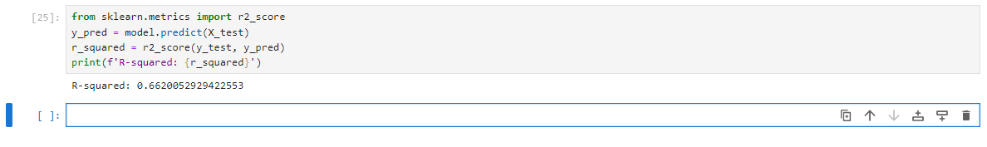

**Persiapan sample dataset**

Training Dataset

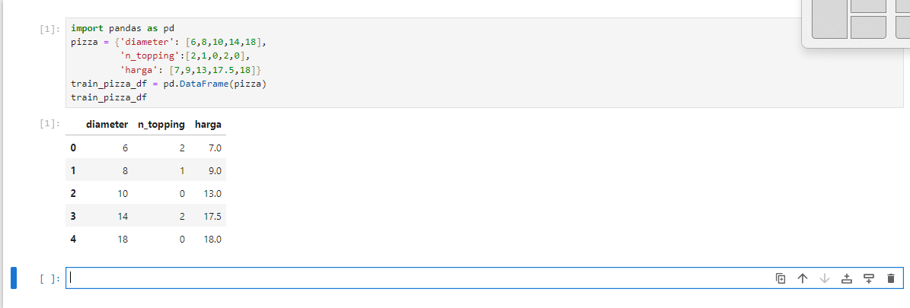

Testing Dataset

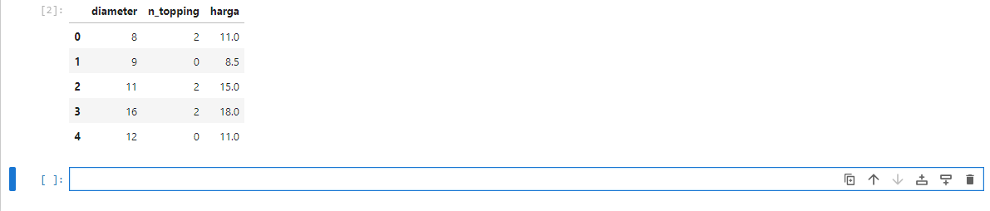

**Preprocessing dataset**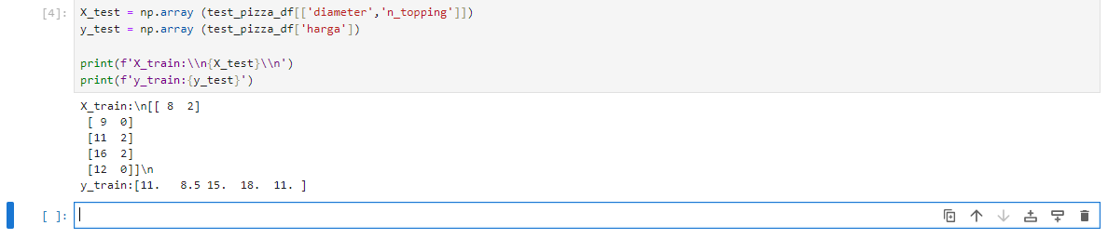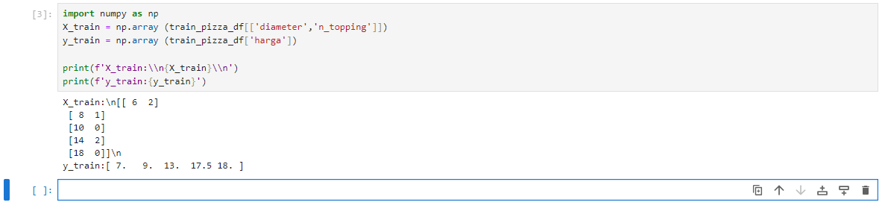

**Multiple Linear Regression**

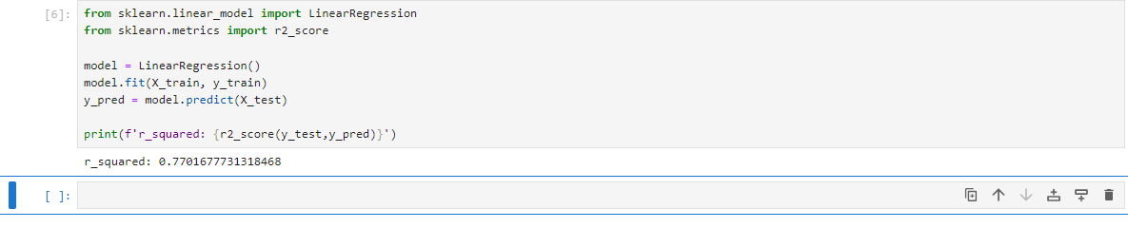

**Polynomial Regression**

Preprocessing Dataset

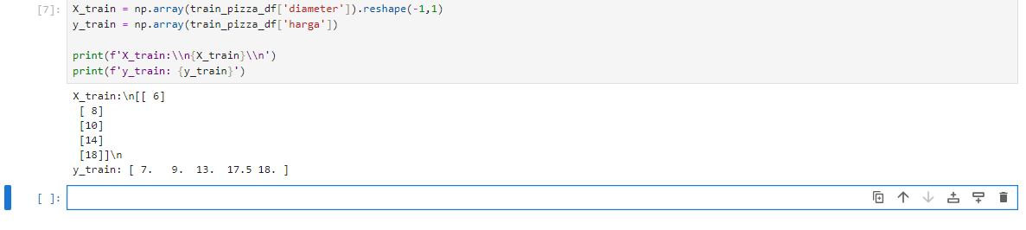

Polynomial Features

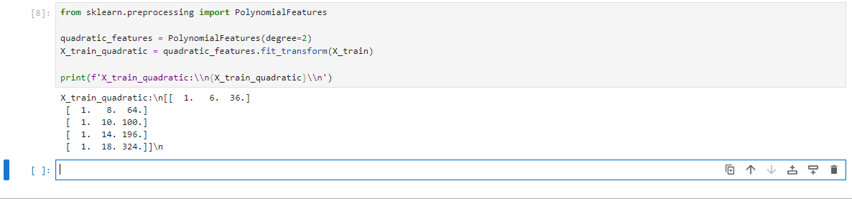

Training Model

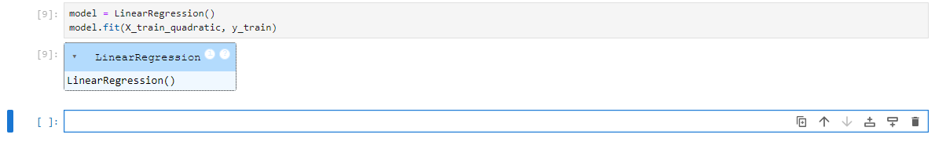

Visualisasi Model

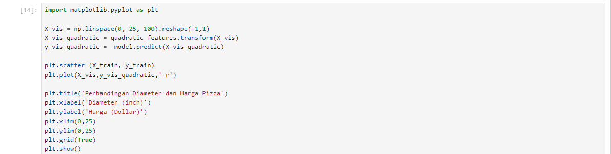

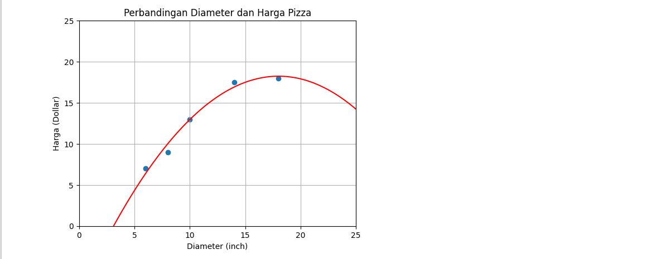

**Quadratic Polynomial Regression**

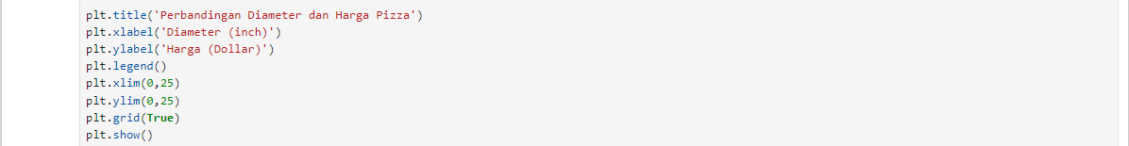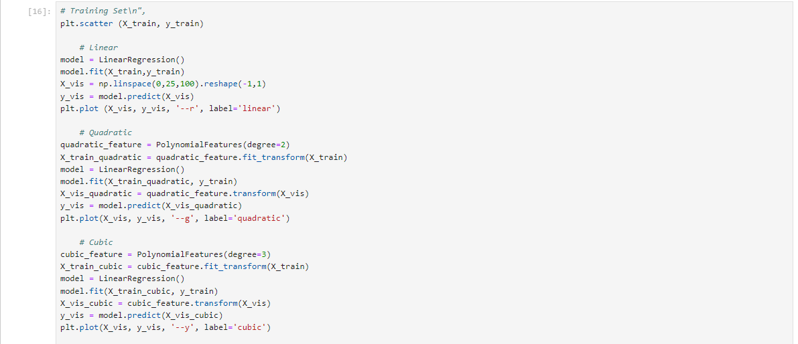

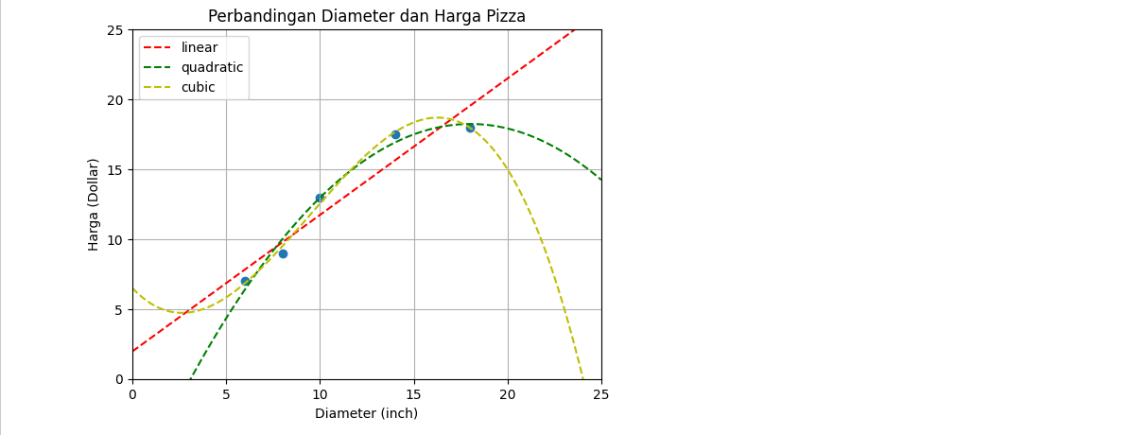

**Dataset SMS Spam Collection Dataset**

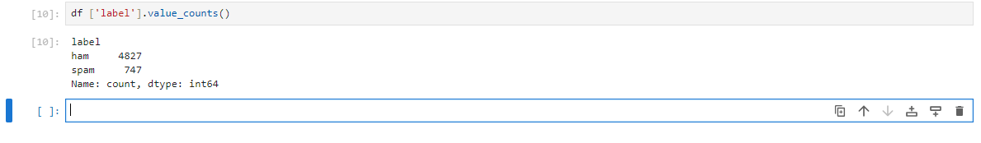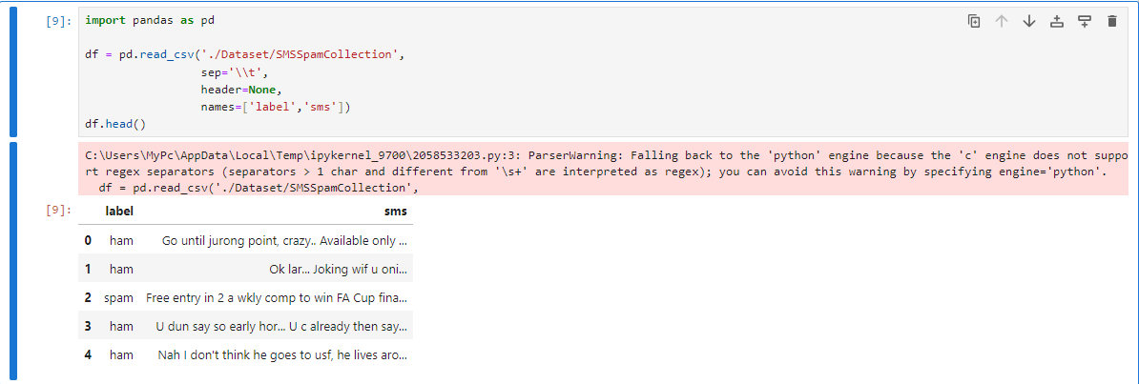

**Training & Testing Dataset**

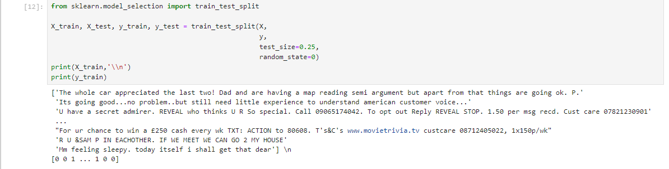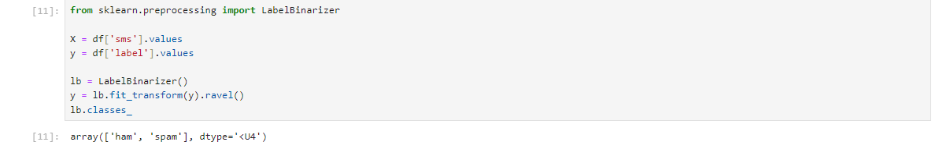

**Feature extraction dengan TF-IDF**

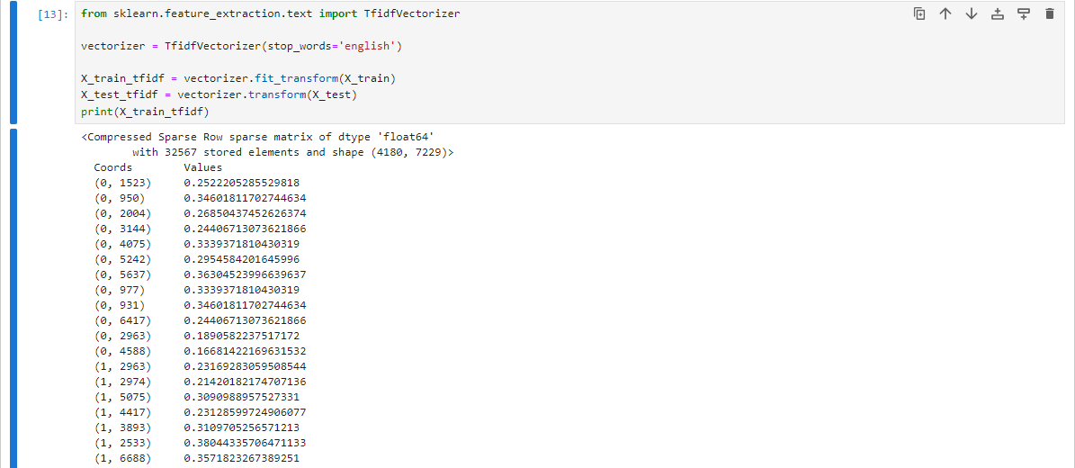

**Binary Classification dengan Logistic Regression**

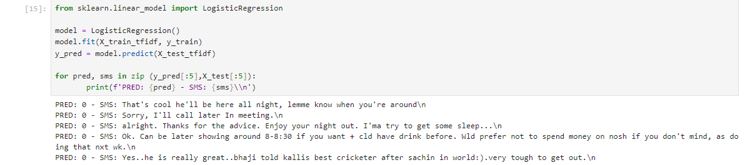

**Evaluation Metrics pada Binary Classification Task**

Confusion matrix

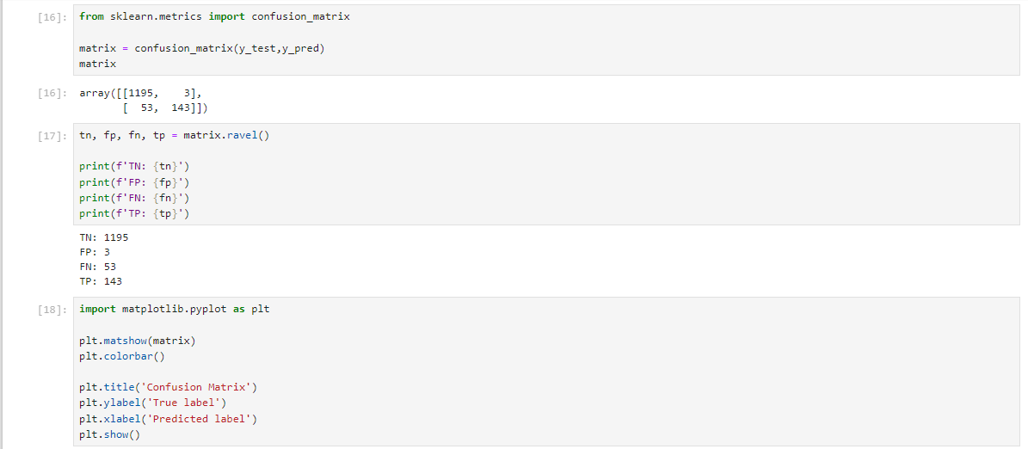

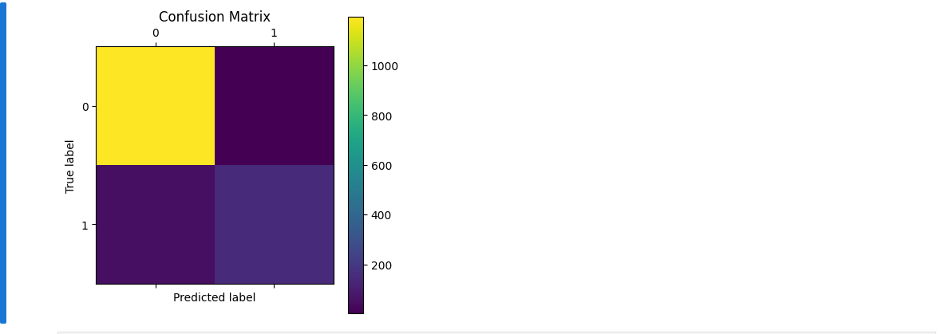

Accuracy



Precission & Recall



Recall



F1-Score



ROC | Receiver Operating Characteristic

